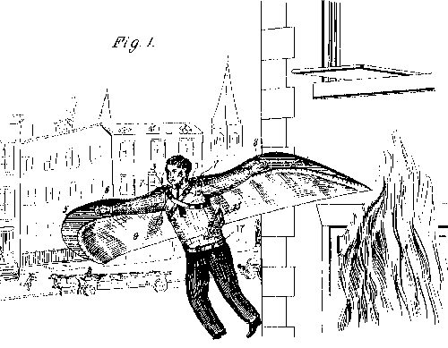
FIRE-ESCAPES
My invention is an improvement in fire escapes, and consists in certain novel constructions and combinations of parts hereinafter described and claimed. Referring to the drawings forming a part hereof Figure 1 shows the improvement in operation. Fig. 2 is a front view of the frame, and the means for attaching it to the body of the wearer. Fig. 3 is a central longitudinal section and Fig. 4 is a detail perspective view of the central portion of the frame showing the hinged connection.
The present embodiment of my invention comprises a frame consisting of a central portion 1, adapted to be placed on the shoulders of the wearer, and having a cutaway portion 2, for receiving the neck. The central portion 1 is provided at each side of the opening with strengthening ribs 3. The side sections 5 are hinged to the ends of the central sections, by a rule joint 6 as shown in Fig. 4. It will he observed that the side sections are curved longitudinally in the plane of the sections, and are provided adjacent to the commencement of the curved portion with loops 8 for engagement by the hands of the wearer as shown in Fig. 1.
The frame is provided with a covering of fabric material 9, and is secured to the body the wearer by means of straps 10, which are riveted or otherwise secured to the central portion of the frame 1, as at 11 the straps crossing and being riveted together as at 12, the upper ends thereof being provided with buckles 13, and the lower ends with spaced openings 14 for engagement by the tongues of the buckles. A strap 15 is secured to the fabric material as at 16, the said strap being endless and forming a loop for engaging a belt 17.
In operation the frame is placed on the wearer's shoulders with the opening 2 engaging the neck, and the crossing of the straps on the back. The free ends of the straps are then brought upwardly under the arms and to the opposite shoulder and into engagement with the buckles, the belt being buckled around the waist of the wearer. The wearer now engages the loops 8 with his hands and is prepared to leap, the air imprisoned beneath the fabric material serving to up-hold the wearer and break the force of his fall.
It will be observed, that the lugs 3 and 6 of the hinged sections permits the frame to open out in alinement or prevents an upward bending of the side sections with respect to the central section, permitting however, a downward movement, so that the frame may be folded together for convenience in carriege or storage.
A fire escape comprising a frame composed of a central section and side sections hinged to the central section, means in connection with the hinges for preventing upward movement of the side sections with respect to the central section, the side sections being curved toward their other ends, a covering of fabric material for the frame, straps connected with the central portion for securing said central portion to the shoulders, a loop connected with the fabric material, a belt engaged with the loop, and loops on the side sections for engagement by the hands of the wearer.
